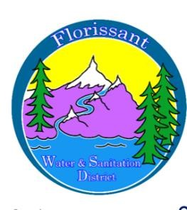

*Florissant Water and Sanitation District*

2244 W. Highway 24, Florissant, CO 80816

NOTICE OF SPECIAL MEETINGS

Public notice is hereby given that two Special Meetings of the Board of Directors of the Florissant Water & Sanitation District are scheduled for:

Saturday, July 12th, 10 a.m. This meeting will be to discuss a proposed rate increase for wastewater. Note, this is a change from the previously scheduled meeting on June 7th.

Wednesday, July 16th, 6 p.m.

These meetings are open to the public and will be held at the Water Plant at the above address. The agenda, if available, will be posted to the District’s website at florissantwsd.colorado.gov.

Date of Notice: 6/2/2025

Next Regular Meeting: Wednesday, 6/11/2025 at 6 p.m.