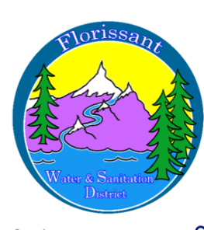

Florissant Water and Sanitation District
2244 W. Highway 24, Florissant, CO 80816
Board Meeting Agenda October 8, 2024, at 6:00 pm at FWSD Building

- Call to Order
Roll Call
Approval of Agenda

- Introduction of Guests

- Consent Calendar
- Approval of Minutes
- Approval to Pay Bills

- Business Meeting
- New Member
- Admin Secretary Report-Bookkeeper Report
- Wastewater/Water Reports-Flushing plan/other for Crystal Peak
- Compliance Report 3rd Quarter-Joan
- Monitoring Plans/SOP

- Executive Meeting-Personnel Matters

- New Business
- Pump for Sanitation
- Rates-compensation for drinking water
- Permit for Sanitation Discharge
- Tank/Money/State meetings
- Next Meeting Nov. 5th?

- Questions/Comments/Next Agenda Items

- Adjournment

Next Board Meeting November 5, 2024, at 6:00 pm

