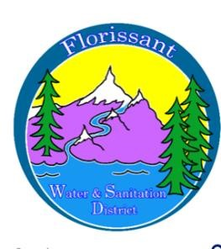

*Florissant Water and Sanitation District*

2244 W. Highway 24, Florissant, CO 80816

NOTICE OF SPECIAL MEETING

Public notice is hereby given that a Special Meeting of the Board of Directors of the Florissant Water & Sanitation District is scheduled for:

Date & Time: Saturday, October 18th, 10 a.m.

Location: Water Plant, 2244 W Hwy 24

Critical capital assets costing over $100,000 must be repaired in order for our water plant to continue functioning. While the board has exhausted grant opportunities and obtained a grant for 50% of this project, the remaining amount must be financed and repaid.

The board will consider public comment at this meeting regarding proposed rate increases in water fees, availability fees, and capital fees to cover this and other operating costs.

Date of Notice: 9/15/25

AGENDA OF SPECIAL MEETING

Date & Time: Saturday, October 18th, 10 a.m.

Location: Water Plant - 2244 W Hwy 24

1. Call to Order

Roll Call

Approval of Agenda

1. Public Comment
2. Determination of Rate Increases and Board Vote
3. Adjournment