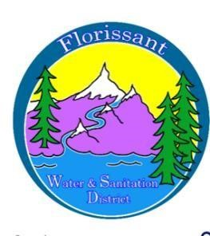
Florissant Water and Sanitation District
2244 W. Highway 24, Florissant, CO 80816
Board Meeting Agenda for Special Meeting October 18, 2025, at 10:00am at FWSD Building

- Call to Order
Roll Call
Approval of Agenda

- Presentation of financials

- Discussion of rate change for availability fees

- Questions/Board Comments

- Discussion of rate change for sewer and water fees

- Questions/ Board Comments

- Adjournment

