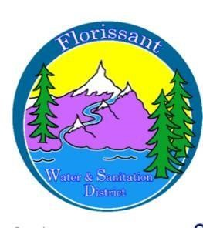

*Florissant Water and Sanitation District*

2244 W. Highway 24, Florissant, CO 80816

Board Meeting Agenda September 10, 2025, at 6:00 pm at FWSD Building

1. Call to Order

Roll Call

Approval of Agenda

1. Introduction of Guests

1. Consent Calendar
   1. Approval of Minutes-vote

1. Business Meeting
   1. Admin Secretary Report/Financials/Pay Bills- vote

* Budget
* DOLA
  1. Wastewater/Water Reports
* Monitoring Plans 2025/SOP-water tests report

1. New Business
   1. Tank Repairs

* Clear Creek Systems bid/Rain for Rent
* Date and notices to public
* Loan for tank
  1. Pipe under bridge repair-sanitation

1. Questions/ Board Comments

1. Adjournment