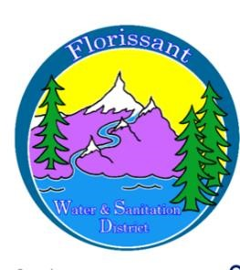
Florissant Water and Sanitation District
2244 W. Highway 24, Florissant, CO 80816
Board Meeting Agenda December 10, 2025, at 6:00 pm at FWSD Building

- Call to Order
Roll Call
Approval of Agenda

- Introduction of Guests

- Consent Calendar
  - Approval of Minutes
  - Approval to Pay Bills

- Business Meeting
  - Wastewater/Water Operator Brief Report
  - Financials/Budget Report-Admin Secretary Brief
  - Budget Adoption

- Next Board Meeting January 14, 2025 at 6:00 pm

- Adjournment

