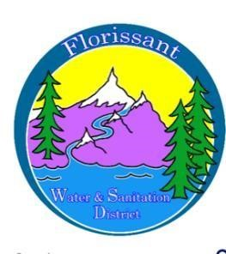
Florissant Water and Sanitation District
2244 W. Highway 24, Florissant, CO 80816
Board Meeting Agenda January 14, 2025, at 6:00 pm at FWSD Building

- Call to Order
Roll Call
Approval of Agenda-vote

- Introduction of Guests

- Consent Calendar
  - Approval of Minutes-vote

- Business Meeting
  - Fire Hydrants-Fire Dept.
  - Admin Secretary Report/Financials/Pay Bills- vote
  - Wastewater/Water Reports
  - Monitoring Plans 2026

- New Business
  - Bookkeeper-interviews
  - Loan-process meeting
  - DOLA-process meeting
  - Survey of system-rates-timelines-RCAC-forgiveness of loans
  - Grants

- Questions/ Board Comments

- Adjournment

