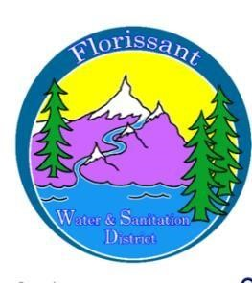

*Florissant Water and Sanitation District*

2244 W. Highway 24, Florissant, CO 80816

Board Meeting Agenda August 13, 2025, at 6:00 pm at FWSD Building

1. Call to Order

Roll Call

Approval of Agenda

1. Introduction of Guests

1. Consent Calendar
   1. Approval of Minutes-vote

1. Business Meeting
   1. Admin Secretary Report/Financials/Pay Bills- vote
   2. Wastewater/Water Reports
   3. Monitoring Plans 2025/SOP-water tests still needed? Kenny report

1. New Business
   1. Tank Repairs-rental of a tanker -Clear Creek Systems
   2. Drop box for documents to be sent-Tonie explains and vote
   3. Recorder-Tonie explains and vote
   4. Pipe under bridge repair-sanitation

1. Questions/ Board Comments

1. Adjournment