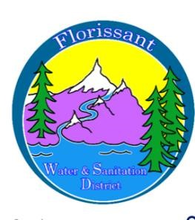

*Florissant Water and Sanitation District*

2244 W. Highway 24, Florissant, CO 80816

Board Meeting Agenda February 11, 2025, at 6:00 pm at FWSD Building

1. Call to Order

Roll Call

Approval of Agenda

1. Introduction of Guests

1. Consent Calendar
   1. Approval of Minutes

1. Business Meeting
   1. Martin Marietta Presentation-project request
   2. Admin Secretary Report/Financials/Pay Bills
   3. Wastewater/Water Reports
   4. Compliance Report-Tank
   5. Monitoring Plans/SOP
2. New Business
   1. Board Policies
   2. Election Forms
   3. RCAC involvement-Rate changes
3. Executive Session-Personnel
4. Questions/ Board Comments -Safety Grant $628.30

-ORC-sanitation

1. Adjournment

Next Board Meeting March 11, 2024, at 6:00 pm