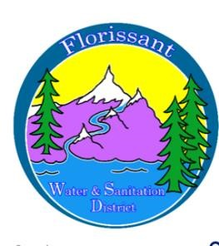

*Florissant Water and Sanitation District*

2244 W. Highway 24, Florissant, CO 80816

NOTICE OF CHANGE IN MEETING TIME

Public notice is hereby given that the regular meeting of the Board of Directors of the Florissant Water & Sanitation District is being changed from the second Tuesday of each month to the second Wednesday of each month, at 6 p.m. at the above address.

These meetings are open to the public. The agenda, if available, will be posted to the District’s website at florissantwsd.colorado.gov.

Date of Notice: 4/3/2025

Next Meeting: Wednesday, 4/9/2025 at 6 p.m.